Sheet 4 (Inheritance)

1. Trace the following code and write what the program prints

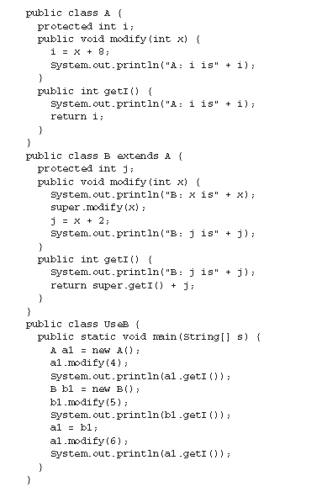

1. What is the output of the following code:

**interface calc {**

**double mileToKM(); double inchToKM(); }**

**interface calcall extends calc {**

**double feetToKM();}**

**class A implements calcall {**

**public static int no = 0; private int KM;**

**public double feetToKM() { return (this.KM * 3281.0);}**

**public double mileToKM() { return (this.KM * 0.6214); }**

**public double inchToKM() { return (this.KM * 39370.0); }**

**public A( ) { this.KM = 0; no = no + 2; }**

**public A(int KM) { this.KM = KM; no = no + 6;}**

**void print() { System.out.println("feet "+ feetToKM() + ", mile "+ mileToKM() + ", inch " +inchToKM());}**

**void print(int x) { System.out.println("Hi parent"); }**

**}**

**class B extends A { private int y;**

**public B( ) { super(6); no = no + 8; }**

**public B( int y) { no = no + 10; this.y = y; }**

**void print() { super.print(); System.out.println("Bye BYe"); print(6); }**

**void print(int x) { System.out.println("Hi child"); }**

**public static void main(String[] args) {**

**B obj = new B(); obj.print();**

**A obj2 = new A(); obj2.print(7);**

**System.out.println("Thanks " + obj2.no);**

**}**

**}**

**Assignment**

1. Trace the following code and write what the program prints

class Singleton {

String word;

static int z;

void doStuff() { z = z + 5;

doStuff2();

word += "Engineer ";

}

void doStuff2() { z++;

word += "Computer ";

}

public Singleton() { word = "Welcome ";

z = 0;

}

public Singleton(int w, String wo) { word = wo;

z = w;

}

}

public class Program extends Singleton {

public Program(int x) {

super(x, "Hi ");

}

public static void main(String[] args) {

Program obj1 = new Program(6);

Singleton obj2 = new Singleton();

obj1.doStuff();

System.out.println(Singleton.z);

System.out.println(obj1.word);

obj1.doStuff2();

System.out.println(Singleton.z);

System.out.println(obj1.word);

obj2.doStuff();

System.out.println(Singleton.z);

System.out.println(obj2.word);

}

}



